SRIP Project 10 Documentation

Compression Test On Spring

Task allotted

1. In virtual-labs repository, pattern-recognition-iiith lab, the task was to resolve

Issue No: 172

2. Issue No: 172 was to Convert following Consolidation Test experiment to JavaScript.

3. Link to the experiment :- http://eerc01-iiith.vlabs.ac.in/exp8/Introduction.html?domain=Civil%20Engineering&lab=Welcome%20to%20Basic%20Engineering%20Mechanics%20and%20Strength%20of%20Materials%20lab!

Experiment Explanation

1) A Coil spring, also known as a helical spring, is a mechanical device, which is typically used to store energy and subsequently release it, to absorb shock, or to maintain a force between contacting surfaces. They are made of an elastic material formed into the shape of a helix which returns to its natural length when unloaded. Metal coil springs are made by winding a wire around a shaped former - a cylinder is used to form cylindrical coil springs.

2) The Compression of the Spring is demonstrated through this experiment.

How to Run the Experiment

1. My forked repository(<https://github.com/singhmayank980/basic-engineering-mechanics-and-strength-of-materials-iiith/tree/srip2019>) contains a folder named “SRIP”.

2. SRIP folder contains folder named as Codes and Libraries. Codes contains all

the files containing code for the experiment written in JavaScript, HTML, CSS.

Libraries contain JavaScript libraries used in the codes.

3. The Codes folder contains 3 files. To run the experiment, simply run the

index.html file by clicking on it.

4. The experiment will open in the browser as shown in the figure below :

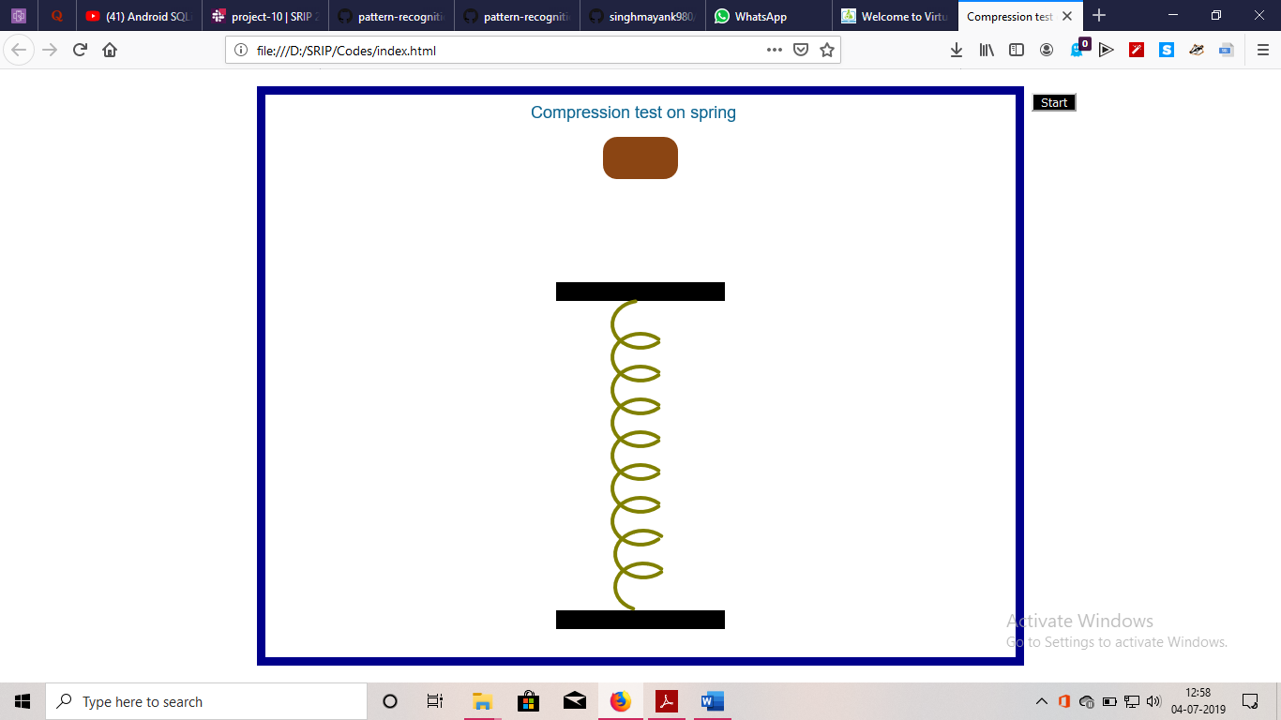

5. After clicking on the ‘Start’ button, demonstration of the Compression of the Spring is illustrated on the browser.

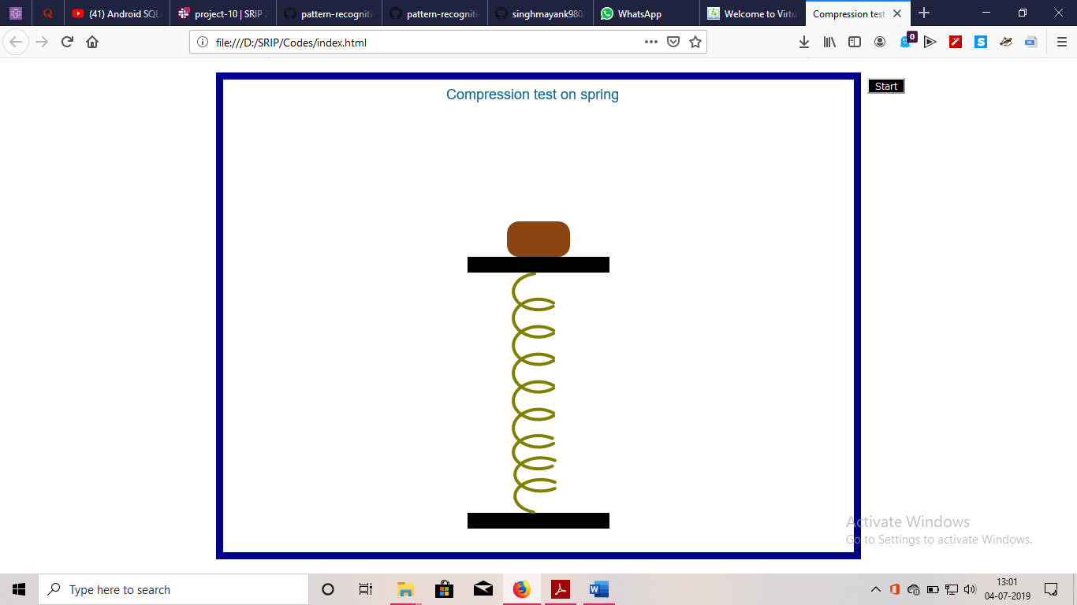

Formulas Used :

1) The potential Energy gets stored in the Spring and is equal to the Potential energy of the Block when at height h in the air.

Initially mgh = ½ k\*x\*x ;

Where m = mass of the block

g = acceleration due to gravity

h = height from where block is dropped.

K = Spring Constant.

x = Change in Spring Length.